Ayush Goyal
190905522 CSE D Roll 62

Compiler Design Lab 2: Preliminary Scanning Applications

Solved Excercise : Removal of single and multiline comments

Code:

#include<stdio.h>
#include<stdlib.h>

int main(){
FILE *fa, *fb;
int ca, cb;
fa = fopen("samplein.c","r");
if(fa == NULL){
printf("Cannot open file!\n");
exit(0);
}
fb = fopen("sampleout.c","w");
ca = getc(fa);
while(ca != EOF){
if(ca == ' '){
putc(ca,fb);
while(ca == ' ')
ca = getc(fa);
}
if(ca == '/'){
cb = getc(fa);
if(cb == '/'){
while(ca != '\n')
ca = getc(fa);
}
else if(cb == '*'){
do{
while(ca != '*')
ca = getc(fa);
ca = getc(fa);
} while(ca != '/');
}
else{
putc(ca, fb);
putc(cb, fb);
}
}
else putc(ca, fb);
ca = getc(fa);
}
fclose(fa);
fclose(fb);
return 0;
}

We create a sample c file called “samplein.c” where we keep both single and multiline comments and we execute our program and get the output in the file “sampleout.c” as shown:

Output:

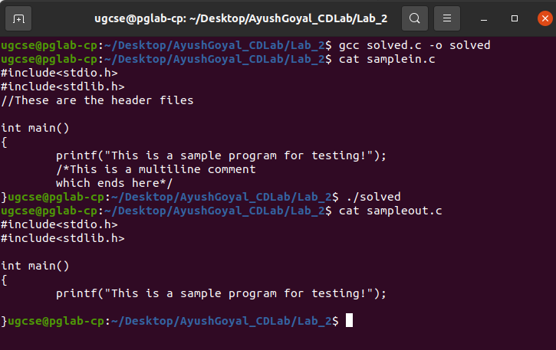

Lab Exercises:

Write a C program:

1. That takes a file as input and replaces blank spaces and tabs by single space and
writes the output to a file.

Code:

#include<stdio.h>
#include<stdlib.h>

int main(){
FILE *fa, *fb;
int ca, cb;
fa = fopen("samplein.c","r");
if(fa == NULL){
printf("Cannot open file!\n");
exit(0);
}
fb = fopen("sampleout.c","w");
ca = getc(fa);
while(ca != EOF){
if(ca == ' ' || ca == '\t'){
putc(' ',fb);
while(ca == ' ' || ca == '\t')
ca = getc(fa);
}
if(ca == '/'){
cb = getc(fa);
if(cb == '/'){
while(ca != '\n')
ca = getc(fa);
}
else if(cb == '*'){
do{
while(ca != '*')
ca = getc(fa);
ca = getc(fa);
} while(ca != '/');
}
else{
putc(ca, fb);
putc(cb, fb);
}
}
else putc(ca, fb);
ca = getc(fa);
}
fclose(fa);
fclose(fb);
return 0;
}

We use a new “samplein.c” file to test the current program and we store the output in “sampleout.c” file. The output is as shown below:

Output:

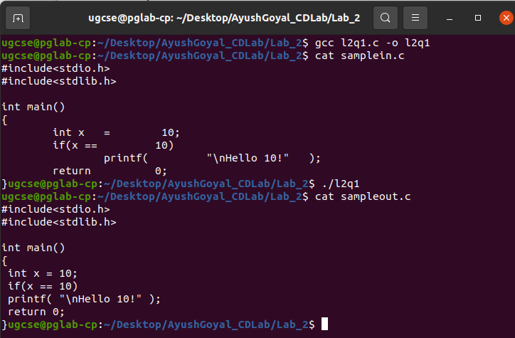

2. To discard preprocessor directives from the given input ‘C’ file.

Code:

#include<stdio.h>
#include<stdlib.h>
#include<string.h>

int main(){
FILE *finp = fopen("samplein.c","r");
FILE *fout = fopen("sampleout.c","w+");
char c = 0;
char buffer[100];
buffer[0] = '\0';
int i = 0;
char *includeStr = "include", *defineStr = "define", *mainStr = "main";
int mainFlag = 0;
while(c != EOF){
c = fgetc(finp);
if(c == '#' && mainFlag == 0){
while(c != ' '){
c = fgetc(finp);
buffer[i++] = c;
}
buffer[i] = '\0';
if(strstr(buffer, includeStr) != NULL || strstr(buffer, defineStr) != NULL){
while(c != '\n'){
c = fgetc(finp);
}
}
else{
fputc('#', fout);
for(int j=0;j<i;j++){
fputc(buffer[j], fout);
}
while(c != '\n'){
c = fgetc(finp);
fputc(c, fout);
}
}
i = 0;
buffer[0] = '\0';
}
else{
if(mainFlag == 0){
buffer[i++] = c;
buffer[i] = '\0';
if(strstr(buffer, mainStr) != NULL){
mainFlag = 1;
}
}
if(c == ' ' || c == '\n'){
buffer[0] = '\0';
i = 0;
}
fputc(c, fout);
}
}
fclose(finp);
fclose(fout);
return 0;
}

We create a new “samplein.c” file to test this program the contents of which is given below. We execute the program and get the required output in “sampleout.c”. We can see all the preprocessor directives have been removed.

Output:

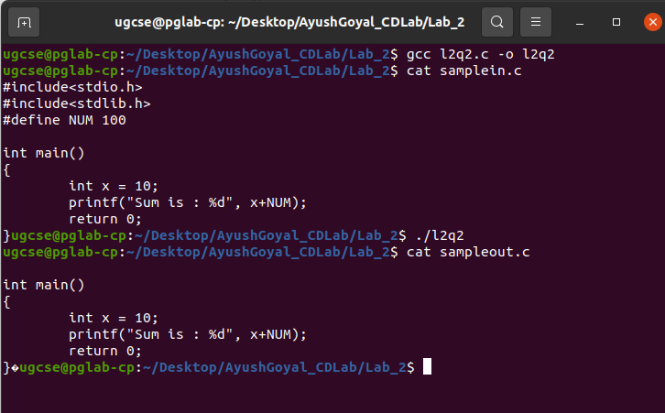

3. That takes C program as input, recognizes all the keywords and prints them in
upper case.

Code:

#include<stdio.h>
#include<stdlib.h>
#include<string.h>
#include<ctype.h>

char keywords[32][10] = {"auto", "double", "int", "struct",
"break", "else", "long","switch", "case", "enum", "register",
"typedef", "char","extern", "return", "union", "const", "float",
"short", "unsigned", "continue", "for", "signed", "void",
"default", "goto", "sizeof", "voltile", "do", "if", "static",
"while"};

int compare(char buffer[]){
for(int i=0;i<32;i++){
if(strcmp(buffer, keywords[i]) == 0){
return 1;
}
}
return 0;
}

int main(){
FILE* fin = fopen("samplein.c","r");
if(fin == NULL){
printf("Cannot find file!\n");
exit(0);
}
char buffer[100], c = 0;
int i = 0;
while(c != EOF){
if(isalpha(c) != 0){
while(isalpha(c) != 0){
c = fgetc(fin);
if(isalpha(c) != 0)
buffer[i++] = c;
}
buffer[i] = '\0';
if(compare(buffer) == 1){
for(int j=0;j<i;j++){
printf("%c", toupper(buffer[j]));
}
printf("\n");
}
i = 0;
buffer[0] = '\0';
}
else{
c = fgetc(fin);
if(isalpha(c) != 0)
buffer[i++] = c;
}
}
fclose(fin);
return 0;
}

Output:

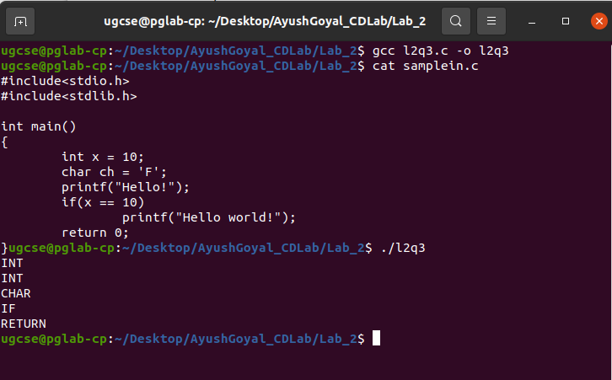
THE END

